International Civil Aviation Organization
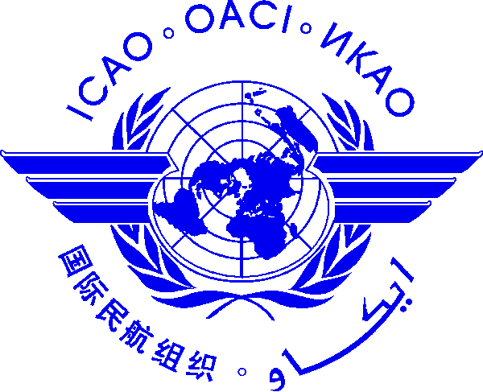 |  | Cooperative Development of Operational Safety and Continuing Airworthiness Programme (COSCAP)  Workshop on the ICAO Cabin Crew Safety Training Manual  (23 to 25 July 2014, Singapore Aviation Academy (SAA), Singapore)  Please register by: 27 June 2014

Nomination Form [please type or print]

State/ Organization
Name | Title |  | Family name (capitals) | First name | Middle initial
Mr.
Ms.
Official Position
Mailing Address
Telephone (office)
Fax
(office)
E-mail
Hotel in Singapore
Date

Note 1: Participants are expected to make their own hotel and visa arrangements.

After completing, please send to:
COSCAP-SEA Administrative Assistant
E-mail: khun.nong@coscap-icao.org
Fax International: +66 2 287 0805

Copy to:
CAA Singapore
Ms. Loh Yhen Shanh
E-mail: loh_yhen_shang@caas.gov.sg

